P3.5 Question
To do...
1) Read the question carefuly
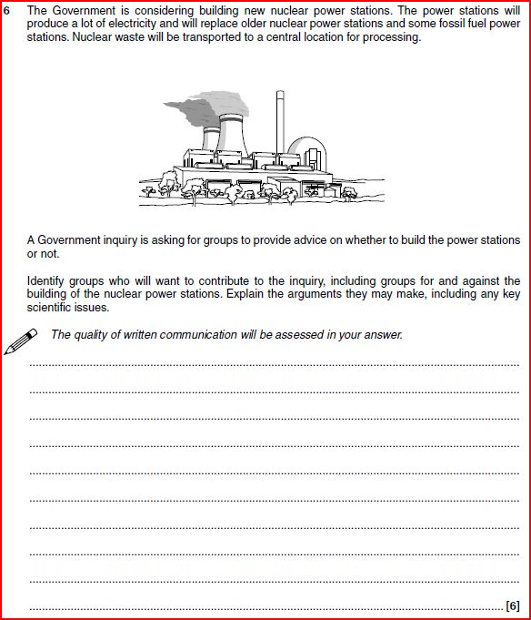

2) What topic is this question about _______________
3) Brainstorm as many of the keywords or phrases that you think should be included in the answer.

4) Now have a think about the order or sequence you would put these keywords or phrases in.

5) Now have a go at answering the question before looking at the mark scheme

P3.5 Answer

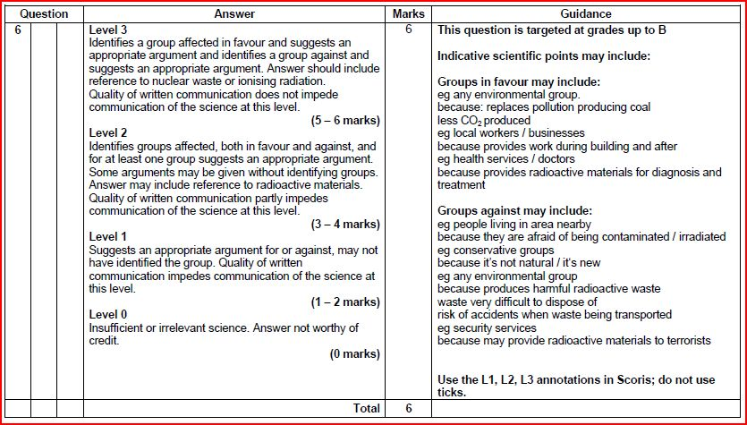

6) Use the mark scheme to see how well you did. Below, see if you can come up with the perfect response

_____________________________________________________________________________________________________________________________________________________________________________________________________________________________________________________________________________________________________________________________________________________________________________________________________________________________________________________________________________________________________________________________________________________________________________________________________________________________________________________________________________________________________________________________________________________________________________________________________________________________________________________________________________________________________________________________________________________________________________________________________________________________________________________________________________________________________________________________________________________________________________________________________________________________________________________________________________________________________________________________________________________________________________________________________________

