Grade A/A*
Many scientists and government officials believe that there is a link between cases of asthma and levels of pollutants in the atmosphere. The graph below looked at cases of asthma in California and subsequent levels of pollutant gases Nitrogen oxide (NO₂), carbon particulates (PM) and carbon monoxide over a 10 year period.

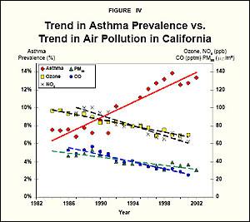

Use the data to evaluate whether there is a correlation between asthma cases and levels of pollutants in the atmosphere and suggest what extra data could be obtained to further test this correlation. (6 marks)

Answers:
- Asthma cases rose steadily between 1982 and 2002
- Cases of CO, particulates and NO2 have all decreased over that period
- From this graph there is no correlation between asthma cases and pollutants in the atmosphere
- May be different data if tested in other areas/times
- Would need causal mechanism to prove how pollutants cause asthma to say there is a definite correlation
- There may be another factor that causes asthma
- No evidence that data has been repeated/when it was collected
- Would need to collect data from other regions/other times of the day/year to look further for a correlation between levels of pollutants and asthma

