[](http://www.oup.com/oxed/secondary/science/c21science)

**GCSE Science**

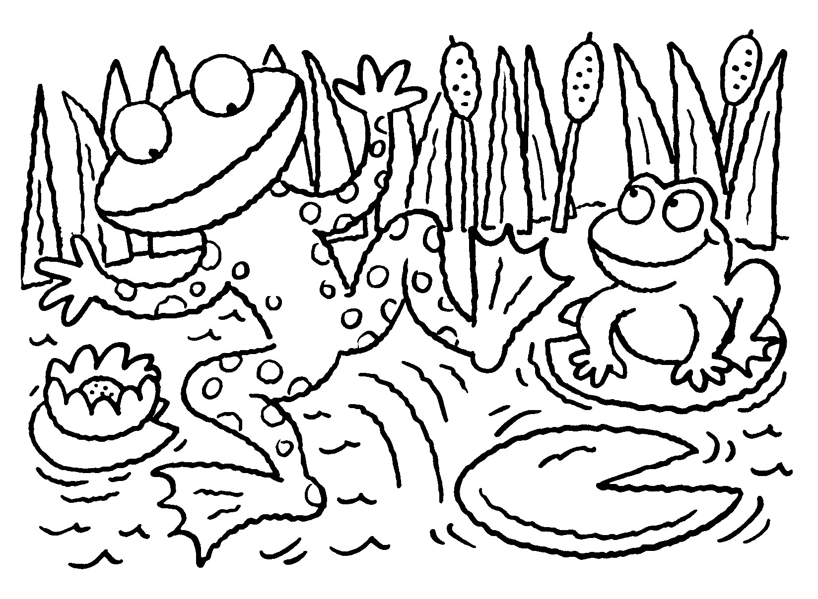

**Module B3 – Life on Earth**

**What you should know**

|  |
| --- |
| **Name:**  **Science Group:**  **Teacher:** |

**R.A.G. each of the statements to help focus your revision:**

*R = Red: I don’t know this*

*Amber: I partly know this*

*G = Green: I know this*

|  |  |
| --- | --- |
| **B3.1 Systems in balance – how do different species depend on each other?** | **R.A.G.** |
| I understand that a species is a group of organisms that can breed together to produce fertile offspring |  |
| I understand that adaptation of living organisms to their environment increases the species’ chance of survival by making it more likely that individuals will survive to reproduce |  |
| I can recall, and recognise when given relevant data, examples of how different organisms are adapted to their environment, and explain how the adaptations increase the organism’s chance of surviving to successfully reproduce |  |
| I understand that living organisms are dependent on the environment and other species for their survival |  |
| I understand that there is competition for resources between different species of animals or plants in the same habitat |  |
| I can relate changes affecting one species in a food web to the impact on other species that are part of the same food web |  |
| **I can** **explain the interdependence of living organisms by using food webs** |  |
| I understand that a change in the environment may cause a species to become extinct, for example, if:  a. the environmental conditions change beyond its ability to adapt |  |
| b. a new species that is a competitor, predator or disease organism of that species is introduced |  |
| c. another species (animal, plant or microorganism) in its food web becomes extinct |  |
| I understand that nearly all organisms are ultimately dependent on energy from the Sun |  |
| I can recall that plants absorb a small percentage of the Sun’s energy for the process of photosynthesis |  |
| I can recall that this absorbed energy is stored in the chemicals which make up the plants’ cells |  |

|  |  |
| --- | --- |
| **B3.1 Systems in balance – how do different species depend on each other? *Continued*** | **R.A.G.** |
| I understand that energy is transferred between organisms in an ecosystem:  a) when organisms are eaten |  |
| b) when dead organisms and waste materials are fed on by decay organisms (decomposers **and detritivores**) |  |
| I can explain how energy passes out of a food chain at each stage via heat, waste products and uneaten parts, limiting the length of food chains |  |
| I can calculate from given data the percentage efficiency of energy transfer at different stages of a food chain |  |
| I understand how carbon is recycled through the environment to include the processes of combustion, respiration, photosynthesis and decomposition |  |
| Iunderstand the importance of the role of microorganisms in the carbon cycle |  |
| I understand how nitrogen is recycled through the environment in the processes of:  **a. nitrogen fixation to form nitrogen compounds including nitrates** |  |
| **b. conversion of nitrogen compounds to protein in plants and animals** |  |
| c. transfer of nitrogen compounds through food chains |  |
| d. excretion, death and decay of plants and animals resulting in release of nitrates into the soil |  |
| e. uptake of nitrates by plants |  |
| **f. denitrification** |  |
| I understand the importance of the role of microorganisms in the nitrogen cycle, including decomposition, **nitrogen fixation and denitrification** |  |
| I can interpret simple diagrams of the carbon cycle and nitrogen cycle |  |

|  |  |  |
| --- | --- | --- |
| **B3.1 Systems in balance – how do different species depend on each other? *Continued*** | | **R.A.G.** |
| I understand how environmental change can be measured using non-living indicators, including nitrate levels, temperature and carbon dioxide levels | |  |
| I understand how climate and environmental change can be measured using living indicators, including phytoplankton, lichens and aquatic river organisms such as mayfly nymphs |  | |
| I can interpret data obtained from living and non-living indicators to investigate environmental change |  | |

|  |  |
| --- | --- |
| **B3.2 How has life on Earth evolved?** | **R.A.G.** |
| I can recall that life on Earth began approximately 3500 million years ago |  |
| I understand that life on Earth (including species that are now extinct) evolved from very simple living things |  |
| I understand that there is variation between individuals of the same species and that some of this variation is genetic so can be passed on to offspring |  |
| I understand that genetic variation is the result of changes that occur in genes (mutations) |  |
| I understand that mutated genes in sex cells can be passed on to offspring and may occasionally produce new characteristics |  |
| I understand the process of natural selection in terms of the effects of genetic variation and competition on survival and reproduction, leading to an increase in the number of individuals displaying beneficial characteristics in later generations |  |
| I can describe the similarities and differences between natural selection and selective breeding |  |
| I can interpret data on changes in a species in terms of natural selection |  |
| I understand how the combined effect of mutations, environmental changes, natural selection and isolation can produce new species in the process of evolution |  |
| I understand that evidence for evolution is provided by the fossil record and from analysis of similarities and differences in the DNA of organisms |  |
| I understand that Darwin’s theory of evolution by natural selection was the result of many observations and creative thought and why it is a better scientific explanation than Lamarck’s (e.g. fits with advances in understanding of genetics, no evidence or mechanism for inheritance of acquired characteristics) |  |

|  |  |
| --- | --- |
| **B3.3 What is the importance of biodiversity?** | **R.A.G.** |
| I understand that organisms are classified into groups according to similarities and differences in characteristics including:  a) physical features (e.g. flowers in flowering plants and the skeleton in vertebrates) |  |
| b. DNA |  |
| I understand that organisms are classified at different levels, and that these levels can be arranged in an order progressing from large groups containing many organisms with a small number of characteristics in common (e.g. kingdom) to smaller groups containing fewer organisms with more characteristics in common (e.g. species) |  |
| I understand that the classification of living and fossil organisms can help to:  a) make sense of the enormous diversity of organisms on Earth |  |
| b) show the evolutionary relationships between organisms |  |
| I understand that biodiversity refers to the variety of life on Earth including:  a. the number of different species |  |
| b. the range of different types of organisms, e.g. plants, animals and microorganisms |  |
| c. the genetic variation within species |  |
| I understand why biodiversity is important for the future development of food crops and medicines |  |
| I understand that the rate of extinction of species is increasing and why this is likely to be due to human activity |  |
| I understand that maintaining biodiversity to ensure the conservation of different species is one of the keys to sustainability |  |
| I understand that sustainability means meeting the needs of people today without damaging the Earth for future generations |  |
| I understand that large-scale monoculture crop production is not sustainable because it does not maintain biodiversity |  |

|  |  |  |
| --- | --- | --- |
| **B3.3 What is the importance of biodiversity?** | **R.A.G.** | |
| I can describe and explain how sustainability can be improved, for example in the use of packaging materials, by considering the materials used, energy used and pollution created |  | |
| I understand why it is preferable to decrease the use of some materials, including packaging materials, even when they are biodegradable, because of:  a. use of energy in their production and transport | |  |
| b. slow decomposition in oxygen deficient landfill sites. | |  |

|  |  |
| --- | --- |
| **Grades A* - C (Higher)** | All statements shown in **bold** as well as all statements shown in normal type. |
| **Grades C – G (Foundation)** | All statements shown in normal type. |