B3 – Life on Earth
Revision questions

- ‘There is a great deal of variation within the living world.’ What is meant by ‘variation’?

- Where does this variation come from?
a)
b)

- What kind of evidence do scientists use to work out what animals are more closely related?

- Explain briefly the relationship between DNA, genes and chromosomes.

- What are alleles?

- What is a ‘mutation’?

- How do mutations occur?

- Briefly explain Lamarck’s theory of acquired characteristics.

- What is the main problem with his theory?

- Briefly explain Darwin’s theory of natural selection.

- Name one way that Darwin and Lamarck’s theories are similar.

- Name one way in which Darwin and Lamarck’s theories are different.

- Darwin wrote his first essay on his theory in 1842, but didn’t publish his book until 1858, because he was worried about what people would say. Why was he worried about public reaction to his theory?

- What is a hominid?

- What evidence is there that hominids are human ancestors?

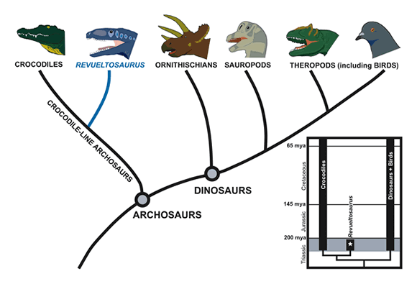
- Choose animals from the evolutionary tree that make these sentences true.
_______________ is a descendent of _______________

______________ is a common ancestor of _____________ and _____________

What is the common ancestor of all animals in this diagram?

- What is the difference between species being ‘endangered’ and ‘extinct’?

- Name 3 endangered species.

- Name 3 extinct species.

- Complete the table:
3 ways humans can cause extinctions | 3 natural causes of extinctions

- Give an example of how a co-extinction might happen.

- Explain how an invasive species might cause another species to go extinct.

- How can climate change cause extinctions?

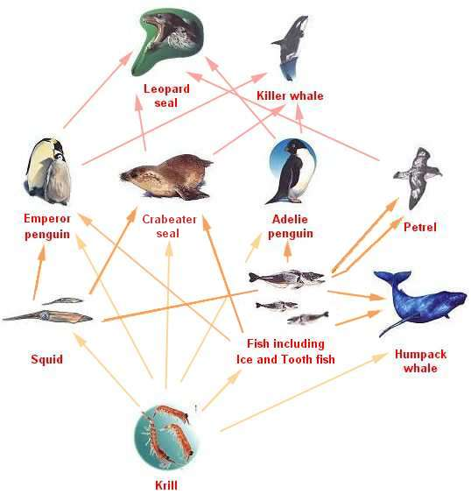
- If pollution causes deaths in leopard seals, what will happen to the number of Emperor penguins? Why?

- a. If the squid are over-fished, what will happen to the population of Crabeater seals? Why?

b. What will happen to the krill population?

- Name 2 animals that are competitors in this food web.

- Name 3 animals that are generalist feeders(not necessarily from the above food web)

- Name 3 specialist feeders.

- In what ways are humans better survivors than other animals? Why are we at the top of the food chain?

- What is biodiversity?

- Why should we care about biodiversity?

- Name 2 habitats/places that have high biodiversity.

- Name 2 habitats/places that have low biodiversity.

- Give at least one reason for the differences in biodiversity.

- What is a ‘stimulus’?

- What is the nervous system?

- What is the endocrine system?

- Complete the table:
 | Endocrine System | Nervous System
Main body parts
Messages are sent via...
Responds quickly or slowly?
Responses are short or long-lasting?
Stimulus. | Receptor. | Coordinator. | Effector. | Response.
Packet of sweets. | Eye. | Brain. | Arm muscle. | Pick up a sweet.
 | Ear. |  | Neck muscles.
Hot iron. |  | Spinal cord. |  | Move hand away.
 | Light sensitive cells in the retina at the back of the eye. |  | Iris. | Enlarges so the pupil gets smaller.
Nettle plant. | Pain receptor in the skin of your leg. |  | Leg muscle. | Move away from nettle.
Now try and write in three of your own ideas for how your nervous system responds to stimulus.

39) Complete the table.

