**Weak**

**Strong Under tension**

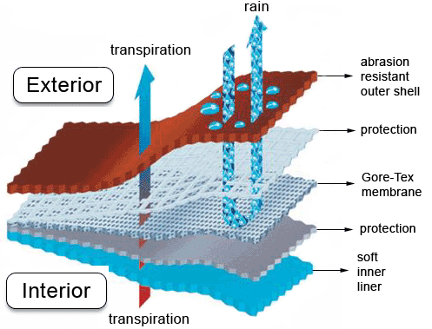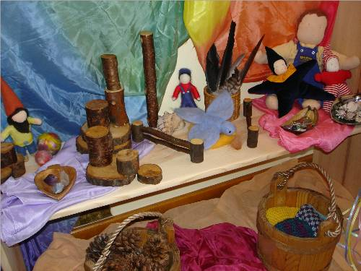 **Synthetic VS. Natural materials**

**SYNTHETIC** = MAN-MADE e.g. nylon, Gore-Tex, Kevlar, Velcro

**NATURAL** = FROM NATURE e.g. wool, cotton, leather, some rubber

**Strong**

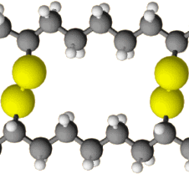

**Vulcanisation**

Adding cross-linking agents links together polymer making material tougher and less flexible.

**Hard**

**Soft**

**Flexible**

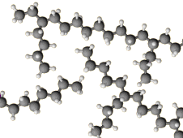

**Branched – Non Crystalline**

* Material = lower density
* Forces of attraction between polymer molecules are weak so material less strong, low melting point

**POLYMERISATION = SMALL MOLECULES JOINING TOGETHER TO FORM LONGER MORE USEFUL ONES**

**Stiff**

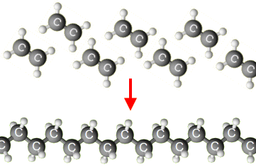

**High Density**

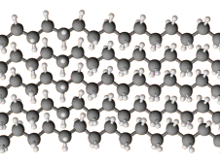

**Crystalline**

* Material = High density
* Forces of attraction between polymer molecules = strong so material stronger, high melting point

**Low Density**

**Low Melting point**

**Strong Under Compression**

**Plasticisers** - added to polymers during manufacture. They push the polymer molecules slightly further apart, weakening the forces between them and making the material softer and more flexible.

Unplasticised PVC, usually called uPVC, is hard. It is used for pipes and window frames. Plasticised PVC is soft. It is used for clothing and flooring.

**High Melting Point**

**Accuracy depends on Quality of apparatus & Skill of the scientists taking the measurement**

**Reliability depends on the variation within the values – to be reliable it must be small**

**Range = the highest and lowest values in a set of measurements**

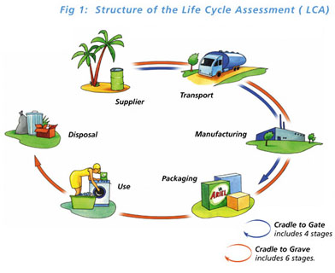

**COST** does not feature in a life cycle assessment?

**RECYCLING** is likely to have the least environmental impact?

The life cycle assessment for a product will be different if we **USE A DIFFERENT MATERIAL**

A uPVC window frame may have less environmental impact than a wooden window frame because it LASTS LONGER

A wooden window frame may have less environmental impact than a uPVC window frame because it **IS MORE SUSTAINABLE**

The life cycle assessment for a material will be different for each PRODUCT