[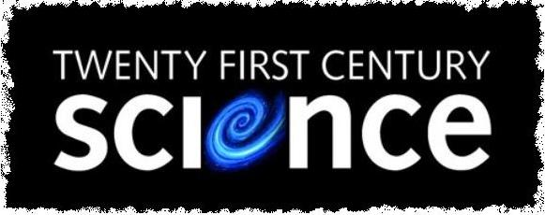](http://www.oup.com/oxed/secondary/science/c21science)

**GCSE Science**

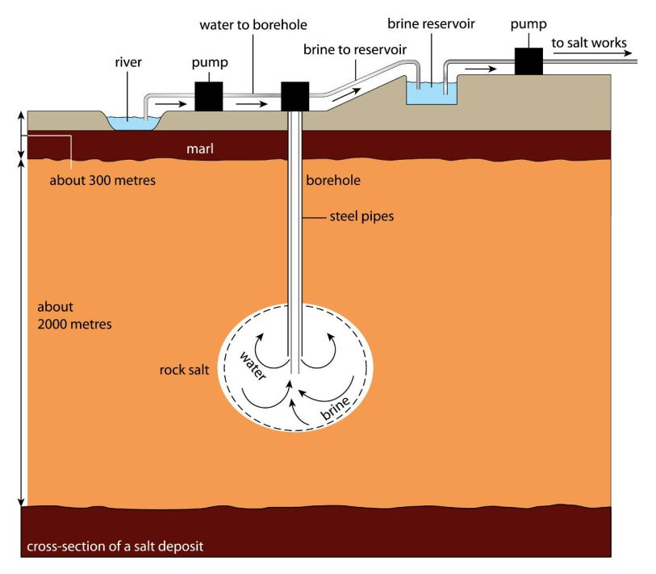

**Module C3: Chemicals in our lives –**

**risks and benefits**

**What you should know**

|  |
| --- |
| **Name:**  **Science Group:**  **Teacher:** |

|  |  |
| --- | --- |
| **C3.1 What were the origins of minerals in Britain that contribute to our economic wealth?** | **R.A.G.** |
| I understand that geologists explain most of the past history of the surface of the Earth in terms of processes than can be observed today |  |
| I understand that movements of tectonic plates mean that the parts of ancient continents that now make up Britain have moved over the surface of the Earth |  |
| I understand how geologists use magnetic clues in rocks to track the very slow movement of the continents over the surface of the Earth |  |
| I understand that the movements of continents means that different rocks in Britain formed in different climates |  |
| I understand how processes such as mountain building, erosion, sedimentation, dissolving and evaporation have led to the formation of valuable resources found in England including coal, limestone and salt |  |
| I understand how geologists study sedimentary rocks to find evidence of the conditions under which they were formed, to include:  a. fossils |  |
| b. shapes of water borne grains compared to air blown grains |  |
| c. presence of shell fragments |  |
| d. ripples from sea or river bottom |  |
| I understand that chemical industries grow up where resources are available locally, e.g. salt, limestone and coal in north west England |  |

|  |  |
| --- | --- |
| **C3.2 Where does salt come from and why is it so important?** | **R.A.G.** |
| I understand the importance of salt (sodium chloride) for the food industry, as a source of chemicals and to treat roads in winter |  |
| I can recall that salt can be obtained from the sea or from underground salt deposits |  |
| I understand how underground salt can be obtained by mining, or by solution in water |  |
| I understand why the method used to obtain salt may depend on how the salt is to be used |  |
| I understand how the methods of obtaining salt can have an impact on the environment |  |
| Iunderstand the advantages of adding salt to food as flavouring and as a preservative |  |
| I can recall the health implications of eating too much salt |  |
| I can evaluate data related to the content of salt in food and health |  |
| I can recall that Government departments, such as the Department of Health and the Department for Environment, Food and Rural Affairs, have a role in:  a) carrying out risk assessments in relation to chemicals in food |  |
| b) advising the public in relation to the effect of food on health |  |

|  |  |
| --- | --- |
| **C3.3 Why do we need chemicals such as alkalis and chlorine and how do we make them?** | **R.A.G.** |
| I canrecall that, even before industrialisation, alkalis were needed to neutralise acid soils, make chemicals that bind natural dyes to cloth, convert fats and oils into soap and to manufacture glass |  |
| I can recall that traditional sources of alkali included burnt wood or stale urine |  |
| I understand that alkalis neutralise acids to make salts |  |
| **I can** **recall that soluble hydroxides and carbonates are alkalis** |  |
| **I can predict the products of the reactions of soluble hydroxides and carbonates with acids** |  |
| I understand that increased industrialisation led to a shortage of alkali in the nineteenth century |  |
| I understand that the first process for manufacturing alkali from salt and limestone using coal as a fuel caused pollution by releasing large volumes of an acid gas (hydrogen chloride) and creating great heaps of waste that slowly released a toxic and foul smelling gas (hydrogen sulfide) |  |
| I understand that pollution problems can sometimes be solved by turning wastes into useful chemicals |  |
| I understand that oxidation can convert hydrogen chloride to chlorine, and that the properties of a compound are completely different from the elements from which it is made |  |
| I can recall that chlorine is used to kill microorganisms in domestic water supplies and as a bleach |  |
| I understand how the introduction of chlorination to treat drinking water made a major contribution to public health |  |
| I can interpret data about the effects of polluted water on health and the impact of water treatment with chlorine to control disease |  |
| I understand that there may be disadvantages of chlorinating drinking water, including possible health problems from traces of chemicals formed by reaction of chlorine with organic materials in the water |  |
| I understand that an electric current can be used to bring about chemical change and make new chemicals through a process called electrolysis |  |
| I can recall that chlorine is now obtained by the electrolysis of salt solution (brine) |  |
| I can recall examples of important uses by industry of the sodium hydroxide, chlorine and hydrogen produced by electrolysis of brine |  |
| I can interpret data about the environmental impact of the large scale electrolysis of brine. |  |

|  |  |
| --- | --- |
| **C3.4 What can we do to make our use of chemicals safe and sustainable?** | R.A.G. |
| I understand that there is a large number of industrial chemicals with many widespread uses, including consumer products, for which there is inadequate data to judge whether they are likely to present a risk to the environment and/or human health |  |
| I understand that some toxic chemicals cause problems because they persist in the environment, can be carried over large distances, and may accumulate in food and human tissues |  |
| I can recall that PVC is a polymer that contains chlorine as well as carbon and hydrogen |  |
| I understand that the plasticizers used to modify the properties of PVC can leach out from the plastic into the surroundings where they may have harmful effects |  |
| I understand that a Life Cycle Assessment (LCA) involves consideration of the use of resources including water, the energy input or output, and the environmental impact, of each of these stages:  a. making the material from natural raw materials |  |
| b. making the product from the material |  |
| c. using the product |  |
| d. disposing of the product |  |
| When given appropriate information from a Life Cycle Assessment (LCA), I can compare and evaluate the use of different materials for the same purpose |  |

|  |  |
| --- | --- |
| **Grades A* - C (Higher)** | All statements shown in **bold** as well as all statements shown in normal type. |
| **Grades C – G (Foundation)** | All statements shown in normal type. |

**R.A.G. each of the statements to help focus your revision:**

*R = Red: I don’t know this A = Amber: I partly know this G = Green: I know this*