Science C1,2,3

Chemistry 1: Air Quality
Unit 1.1: The changing air around us (Pg. 23)
Air composition: (Dry air)
78% : Nitrogen
21% : Oxygen
1% : Argon and small volumes of other gases

Clouds are made up of water or ice.
Dust are made up of solids, they are not part of the air.

Oxygen reacts with most metals to make solids metal oxides.
To find out percentage of oxygen in the air we can pass air over heated copper.

The Earth's atmosphere was approximately found 4 billion years ago, by the gases given out by volcanoes; Carbon Dioxide, Water Vapour, Lava, Dust.

- 4 billion years ago the Earth's atmosphere was very hot. As the Earth cooled down, oceans formed from the condensed water.
- About 1 billion years after, simple bacteria-like creatures evolved to use photosynthesis. This removed carbon dioxide from air, and released oxygen, allowing organisms to evolve.
- Carbon dioxide was removed by plants and animals dying and becoming buried. Over millions of years some of the buried material became fossil fuels.
- Carbon dioxide dissolved in oceans reacts with salts to form insoluble calcium carbonate. This forms sediments which become buried and cemented to form sedimentary rocks.

Ideas of the composition of the Earth's atmosphere have changed over time:
- Sixty years ago many scientists thought the early atmosphere was largely ammonia and methane.
- Recent rock composition discoveries showed early ideas were not correct, and the early atmosphere was largely carbon dioxide.

Unit 1.2: Humans, air quality and health

Pollutants are gases that are harmful to our health, E.g: Carbon monoxide, Nitrogen oxides & Sulphur dioxide.

Pollutants are harmful to the environment, people and animals living there.

Sulphur dioxide and Nitrogen dioxide cause acid rain.
Carbon dioxide is linked to climate change.

Human activity is increasing the gas levels in the atmosphere

Carbon Dioxide is measure in parts per million (PPM).
Carbon Monoxide, Nitrogen Oxides & Sulphur dioxide are measure in parts per billion (PPB).

The amount of gases are measured by air quality monitors – Data transmits to a computer for analysis.

Correlation: Link between a factor and an outcome.

Unit 1.3: Burning fuels

Oxygen is needed for any fuel to burn and release energy.

Hydrocarbons = Fossil fuels.
Only contain carbon & hydrogen.

When hydrocarbons burn:
Hydrocarbon fuel + Oxygen → Carbon dioxide + Water (+ Energy)

Oxidation: When oxygen is added to a substance
Reduction: When oxygen is removed from a substance
Combustion: An oxidation reaction. (Burning)

Atoms do not change! - They get rearranged.
Molecules: When atoms of non-metal elements join.
Compounds: Elements rearrange and react with each other.

Mass is conserved in a reaction.
The number and type of elements stay the same.

Sulphur = Solid and Yellow
Sulphur Dioxide = Colourless
Sulphur is insoluble, but sulphur dioxide can dissolve in water.

Sulphur + Oxygen → Sulphur Dioxide
Acid rain indirectly harms us.

Unit 1.4: Pollution

Power stations and transport cause most pollution.

Sulphur dioxide is made if fuels contain sulphur.
Carbon dioxide is always made when fuel is burned.
Incomplete combustion creates carbon monoxide.

Car engines make nitrogen oxides – at high temperatures.

NOx damages buildings, contributes to acid rain and can affect health.

Carbon atom colours:
Black = Carbon
White = Hydrogen
Red = Oxygen
Yellow = Sulphur
Blue = Nitrogen

Pollutants are removed from air when:
- Particulates settle on surfaces
- Sulphur & Nitrogen oxides react with oxygen/water
- Photosynthesis (CO2)
- Dissolves in rain water/oceans (CO2)

Mean = A good estimate of true value
Range = Difference between high and low result
Removing outliers could lead to mistakes.

Unit 1.5: Improving power stations and transport

Improving power stations:
- Removing electricity
- Turning things off, not standby
- Burning less
- Removing sulphur from oil and gas before burning
- Flue gas desulfurisation

Flue-gas desulfurisation (FGD) is a set of technologies used to remove sulphur dioxide (SO2) from exhaust flue gases of fossil-fuel power plants, and from the emissions of other sulphur oxide emitting processes.

Two 'wet scrubbing ' methods used to remove sulphur dioxide from power stations waste gases are:
- Using an alkaline slurry of calcium oxide (lime) and water to make calcium sulphate.
- Using sea water; absorbs the sulphur dioxide
Alternatives to fossil-fuel:
- Biofuels E.g: wood chips, palm oil
- Renewable energy E.g: Solar, Biomass, Wind, Geothermal heat

Air pollution can be reduced by:
- Using less cars
- Using cleaner fuels
- Removing pollutants from exhaust
- More frequent use of public transportation

Catalytic convertors:
Carbon monoxide + Nitrogen monoxide → Nitrogen + Carbon dioxide.
Carbon monoxide gains oxygen; oxidised.
Nitrogen monoxide loses oxygen; reduced.

Legal limits for exhaust emissions are enforced by strict MOT test.

Electric cars do not give out pollutant gases, but the electricity used for charging does.

Chemistry 2: Material choices
Unit 1.1: Using and choosing materials

Each material has properties that make it suitable for the job is it doing:
- Rubber is used for car tyres because it's hard and elastic
- Fibres are used to weave cloth into clothes
- Plastics keep their shape when moulded into objects like washing-up bowls.

Properties describe how a material behaves.
- Melting point is the temperature at which a solid turns into a liquid
- Tensile strength is the force needed to break a material when it is being stretched
- Compressive strength is the force needed to crush a material when it is being squeezed
- Stiffness is the force needed to bend a material
- Hardness is how well a material stands up to wear. Compared by scratching two materials together
- Density is the mass of a given volume of material. Compares how heavy something is for its size.

Density is mass per unit volume. (g/cm^3)

Unit 1.2: Natural and synthetic materials

All the materials we use are chemicals or mixtures of chemicals.
- Metals are chemicals which are shiny, malleable and electrical conductors.
- Ceramics include clay, glass and cement.
- Polymers are large molecules used to make rubbers, plastics and fibres.

Natural materials from living things which need little processing are cotton and paper from plants and silk and wool from animals.

Other naturals raw materials which are extracted from the Earth's crust are limestone, iron ore and crude oil.

Synthetic materials are manufactured by chemical reactions using raw materials.
Synthetic materials have replaced naturals materials because:
- some natural materials are in short supply
- are designed to give particular properties
- often cheaper

Crude oil (petroleum) is a mixture of thousands of hydrocarbons.

The number of atoms of each element in the reactants must be the same in the products.

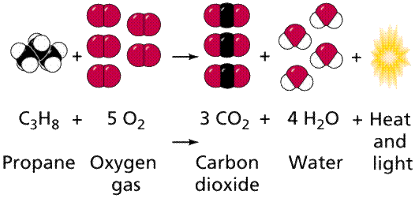
Crude oil consists mainly of a mixture of hydrocarbons, which are chain molecules of varying lengths up to 100 carbon atoms long.

Unit 1.3: Separating crude oil

Crude oil is separated by fractional distillation:
- The oil is heated up which turns it all into gases.
- The distillation tower gets cooler as it gets higher
- Gas molecules condense into liquids when they cool
- Liquids with similar boiling points collect together, called fractions.
Hydrocarbons in each fraction have boiling points within a range of temperature.
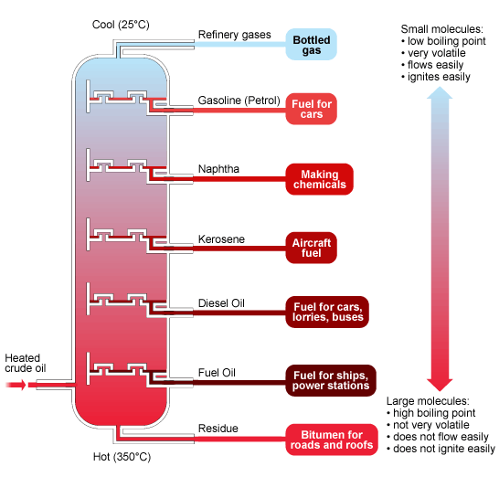

The smaller the molecule chain length, the lower the boiling point.
The smaller the molecule chain length, the smaller the forces between molecules.

Larger molecules need more energy to break them out of a liquid to from a gas, so have higher boiling points.

A polymer is a larger molecule made by joining many smaller molecules called monomers. A polymer can have a chain of anything from hundreds to million of carbon atoms.

A polymer is made by a process called polymerisation.
Ethene is a monomer used to make polyethene.

Material choice will depend on comparing properties for different jobs, with cost being a factor.

Unit 1.4: Polymers: properties and improvements

Small forces attract molecules to each other.
The forces are strongest when the molecule are close together.

The properties of polymers depend upon how their molecules are arranged and held together.
Low density polyethene (LDPE), E.g: plastic carrier bags, has long molecules with branches. The branches keep molecule chains apart, so forces between different molecules are weak.

High density polyethene (HDPE), E.g: water pipes, has long chains but no branches so the molecules are aligned close to each other. HDPE is much stronger and is used to make long lasting items.

HDPE has a high degree of crystallinity. This means there are lots of areas with regular patterns in the way the molecules line up.
High crystalline polymers are strong with high melting point, but can be brittle.

Plasticisers are used to make a polymer softer. They are small molecules inserted into polymer chains to keep them apart, weakening the forces.

Thermoplastics soften when heated and can be moulded into shape.
Thermosetting plastics do not soften when heated. They contain cross-links which lock the molecules together so they cannot melt.

Unit 1.5: Nanotechnology and nanoparticles

Nanoparticles are materials containing up to a thousand atoms.
They:
- occur naturally, such as salt in seaspray
- occur by accident, such as solid particulates made when fuels burn
- can be designed in laboratories

Nanotechnology is the use and control of very small structures, which are measured in nanometres (nm).
A nanometre is one millionth of a millimetre.

Some nanoparticles are effective catalysts as they have a large surface area. Increasing surface area provides more sites for reactions to take place.

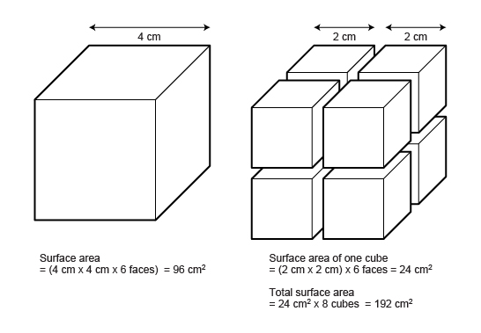

1,000 millimetres = 1m so, 1mm = 1 x 10^-3m
1,000,000 micrometres = 1m so, 1 µm = 1 x 10^-6m
1,000,000,000 nanometres = 1m so, 1nm = 1 x 10^-9m

Unit 1.6: The use and safety of nanoparticles

Silver nanoparticles are very good at killing bacteria. They can be added to fibres and woven into socks, put into wound dressings, put into plastic and made into food containers.

Titanium oxide nanoparticles are put into sunscreen. They make the sunscreen transparent and absorb UV light.

Nanoparticles can be mixed with other materials like metals, ceramics and plastics, called composites.
Composite materials are stronger and more hard-wearing.
Adding nanoparticles to:
- plastic sports equipment makes it stronger
- tennis balls make them stay bouncer for longer
- rubber used In tyres make them harder wearing.

Silver nanoparticles can be washed out of clothes and get into sewage works.
Sewage works use bacteria to clean water. Silver nanoparticles could kill these useful bacteria.
Silver nanoparticles could also kill lots of useful micro-organisms if released into the environment.

Nanoparticles are small enough to pass through skin into blood, and into body organs. The possible medical effects of this are not yet known.

Nanoparticles are feared to cause lung or brain damage.

Chemistry 3: Chemicals in our lives: risks and benefits
Unit 1.1: Moving continents and useful rocks

ACID + ALKALI → SALT + WATER

Geologists can date rocks and track the slow movements of continents through changes in magnetic patterns, which are linked to radioactive decay.

The Earth's magnetic field changes over time.
Change happens by slow movements of tectonic plates.
Igneous rock form when lava solidifies.

Limestone formed while Britain was covered in sea:
- Shellfish died forming sediments on the sea bed.
- Sediments compacted and hardened to form limestone, a sedimentary rock.
- Tectonic plate movements pushed the rock to the surface
- Gradually the rocks above were eroded away until the limestone was exposed.

Coal formed in wet swampy conditions when plants like trees and ferns died and became buried. This excluded oxygen, slowly down the decay.

Salt formed while Cheshire was covered by a shallow sea:
- Rivers brought dissolved salts into the sea
- Climate warming evaporated the water, leaving the salt that mixed with sand blown in by the wind
- Rock salt formed and was buried by other sediments
Ripple marks in rocks indicate water flow from rivers or waves in the sea.
Rock salt contains different-shaped water-eroded grains and wind-eroded grains.
Limestone contains bits of shell fragments from sea creatures.
Coal contains fossils of the plants that formed it.

Unit 1.2: Salt

Salt = NaCl
Salt is an important raw material, without it there would be an environmental impact.

Rock salt is insoluble. As it contains grains of sand, there is grip.

Mining for salt can allow water to flow into the mines, which may let salt flow out into water supplies, contaminating them.

Risks of easting salt in foods:
- High blood pressure
- Prevents bacteria growth
- Heart failure
- Strokes
This means salts is classified as a hazard.

A risk is the chance of getting ill, and the consequences if you did.
Risks can be estimated by measuring salt intake.

Unit 1.3: Reacting and making alkalis

Alkalis made indicators change colour.
Litmus paper turns blue in alkalis and red in acids.

Alkalis are used for:
- dying cloth;
- neutralising acid soil;
- making soap;
- making glass.

In coastal areas, seaweed or seaweed ash (soda) could be used to neutralise acidic soils.

In 1787, Nicholas Leblanc discovered how to manufacture an alkali.
The Leblanc process made sodium carbonate by reacting salt and limestone, heating with coal.
It gave off large amounts of hydrogen chloride. It also produced heaps of solid waste that slowly released hydrogen sulphide, a foul-smelling, toxic gas.

Later, a process was invented to change the harmful hydrogen chloride into useful substances:
- chloride used to bleach textiles prior to dying.
- Hydrochloric acid, which is a starting material for making other chemicals
Oxidation converts hydrogen chloride to chlorine.

Alkalis = Greater than 7, Blue or Violet pH colour
They are soluble metal hydroxides or carbonates.

Metal hydroxide/carbonates are normally insoluble; bases.

Hydroxide + Acid → Salt + Water
Carbonates + Acid → Salt + Water + Carbon dioxide

Unit 1.4: Electrolysis

Electrolysis breaks up compounds using electricity.
The electrolysis of brine makes:
- Chlorine gas
- Hydrogen gas
- Sodium hydroxide

Anode – Positive electrode
Cathode Negative electrode

During brine electrolysis, chlorine forms at the anode and hydrogen at the cathode.

Uses of the three product:
- chloride for making plastics like PVC, in medicines and crop protection
- hydrogen for making margarine, as rocket fuel, in fuel cells in vehicles
- sodium hydroxide for paper recycling, industrial cleaners and refining aluminium.

Unit 1.5: Safe?

To decide the level of risk of a particular chemical we need to know:
- how much of it is needed to cause harm
- how much will be used
- the chance of it escaping into the environment
- who or what it may affect

A Life Cycle Assessment (LCA) measures the energy used to make, use and dispose of a substance, and its environmental impact.

At each stage of an LCA we need to consider:
- How much natural resources are required?
- How much energy is needed or produced?
- How much water and air is used?
- How is the environment affected?
To produce a fair and accurate LCA, a lot of data is required.

